UNITED STATES

SECURITIES AND EXCHANGE COMMISSION

Washington, D.C. 20549

FORM 6-K

REPORT OF FOREIGN PRIVATE ISSUER

PURSUANT TO RULE 13a-16 OR 15d-16 UNDER

THE SECURITIES EXCHANGE ACT OF 1934

For the month of July 2024

Commission file number: 001-34936

Noah Holdings Limited

No.1226, South Shenbin Road, Minhang District,

Shanghai, People’s Republic of China

+86 (21) 8035-8292

(Address of Principal Executive Offices)

Indicate by check mark whether the registrant files or will file annual reports under cover Form 20-F or Form 40-F.

Form 20-F ☒ Form 40-F ☐

EXHIBIT INDEX

Exhibit 99.1 Announcement—Payment of Final Dividend and Special Dividend

Exhibit 99.2 Announcement—Final Dividend for the Year Ended December 31, 2023 (Updated)

Exhibit 99.3 Announcement—Special Dividend (Updated)

SIGNATURE

Pursuant to the requirements of the Securities Exchange Act of 1934, the registrant has duly caused this report to be signed on its behalf by the undersigned, thereunto duly authorized.

Noah Holdings Limited

By: /s/ Qing Pan

Name: Qing Pan

Title: Chief Financial Officer

Date: July 5, 2024

Exhibit 99.1

Hong Kong Exchanges and Clearing Limited and The Stock Exchange of Hong Kong Limited take no responsibility for the contents of this announcement, make no representation as to its accuracy or completeness and expressly disclaim any liability whatsoever for any loss howsoever arising from or in reliance upon the whole or any part of the contents of this announcement.

Noah Holdings

Noah Holdings Private Wealth and Asset Management Limited

諾亞控股私人財富資產管理有限公司

(Incorporated in the Cayman Islands with limited liability under the name Noah Holdings Limited and carrying on business in Hong Kong as Noah Holdings

Private Wealth and Asset Management Limited)

(NYSE Ticker Symbol: NOAH; HKEX Stock Code: 6686)

PAYMENT OF FINAL DIVIDEND AND SPECIAL DIVIDEND

Reference is made to the announcement (“Announcement”) of Noah Holdings Private Wealth and Asset Management Limited (the “Company”) dated June 12, 2024 in relation to the payment of final dividend and special dividend, respectively. Unless the context requires otherwise, capitalized terms used in this announcement shall have the same meanings as those defined in the Announcement.

The Board is pleased to announce that the Company will distribute (i) the Final Dividend of HK$1.65 per Share (for registered holders of the ordinary shares in Hong Kong) (tax inclusive) in Hong Kong dollars or US$0.21 per Share (for ADS holders and for holders of ordinary shares whose shares are registered on the Company’s principal share register in the Cayman Islands) (tax inclusive) in U.S. dollars in respect of the year ended December 31, 2023, calculated based on the Final Dividend of RMB1.54 per Share (tax inclusive); and (ii) the Special Dividend of HK$1.65 per Share (for registered holders of the ordinary shares in Hong Kong) (tax inclusive) in Hong Kong dollars or US$0.21 per Share (for ADS holders and for holders of ordinary shares whose shares are registered on the Company’s principal share register in the Cayman Islands) (tax inclusive) in U.S. dollars, calculated based on the Special Dividend of RMB1.54 per Share (tax inclusive), both with reference to the effective noon buying rate for June 28, 2024 as set forth in the H.10 statistical release of the U.S. Federal Reserve Board and the number of issued Shares (excluding treasury Shares) of 330,686,753 entitled to dividend distribution as of the Dividend Record Date (i.e., July 3, 2024).

For the distribution of the Final Dividend and Special Dividend to ADS holders, the final amounts of approximately US$1.06 and US$1.06 per ADS (subject to applicable tax and depositary fees) are payable in U.S. dollars to the Company’s ADS holders through the depositary bank subject to the foreign exchange rate adjustment on the date of settlement in accordance with the terms of the deposit agreement.

1

The Final Dividend and Special Dividend are expected to be distributed on or around July 25, 2024 to eligible Shareholders, and on or around August 1, 2024 to eligible ADS holders. Shareholders and ADS holders should seek professional advice from their own tax advisors regarding the possible tax implications of the payment of the Final Dividend and the Special Dividend.

By order of the Board

Noah Holdings Private Wealth and Asset Management Limited

Jingbo Wang

Chairwoman of the Board

Hong Kong, July 4, 2024

As of the date of this announcement, the Board comprises Ms. Jingbo Wang, the chairwoman and Mr. Zhe Yin as Directors; Ms. Chia-Yue Chang, Mr. Kai Wang, Mr.

Boquan He and Mr. David Zhang as non-executive Directors; and Ms. Xiangrong Li, Ms. Cynthia Jinhong Meng and Ms. May Yihong Wu as independent Directors.

2

Exhibit 99.2
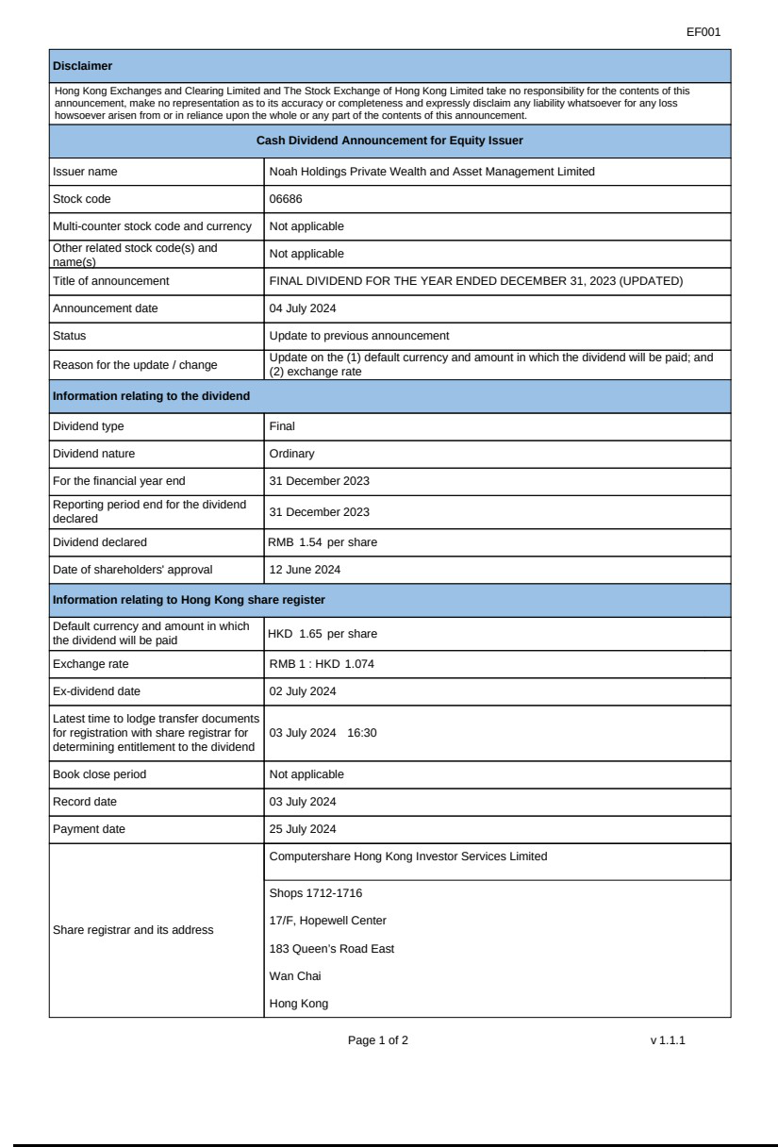

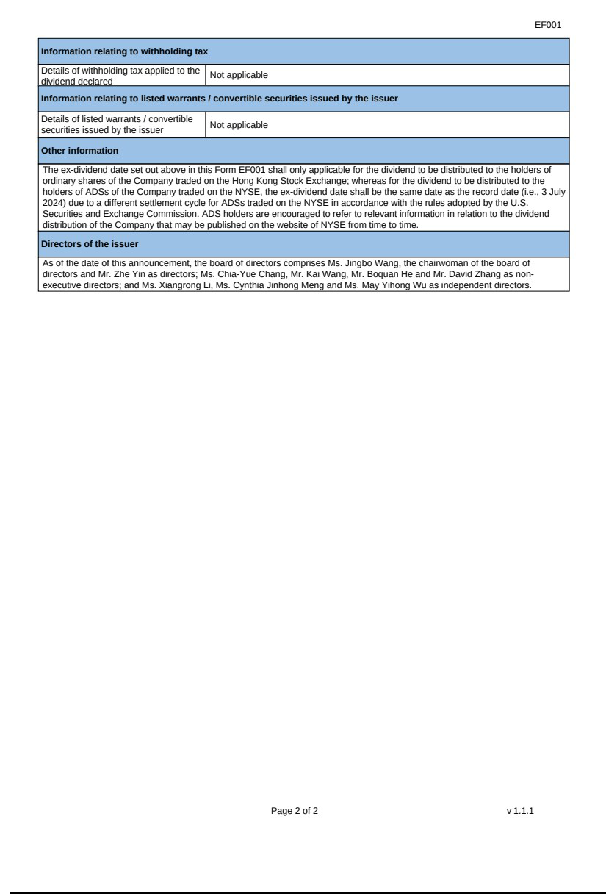

Exhibit 99.3


