UNITED STATES
SECURITIES AND EXCHANGE COMMISSION
Washington, D.C. 20549

Form 6-K

REPORT OF FOREIGN PRIVATE ISSUER PURSUANT TO RULE
13a-16 OR 15d-16 UNDER
THE SECURITIES EXCHANGE ACT OF 1934

For the month of June 2026

Commission File Number: 001-34936

Noah Holdings Limited
(Registrant’s name)

333 North Bridge Road, #05-11
Odeon 333
Singapore 188721
+65 6911-8211
(Address of principal executive office)

Indicate by check mark whether the registrant files or will file annual reports under cover Form 20-F or Form 40-F.

Form 20-F ☒ Form 40-F ☐

EXHIBIT INDEX

Exhibit 99.1 | Next Day Disclosure Return Dated June 3, 2026

SIGNATURE

Pursuant to the requirements of the Securities Exchange Act of 1934, the registrant has duly caused this report to be signed on its behalf by the undersigned, thereunto duly authorized.

 | Noah Holdings Limited
 | By: | /s/ Qing Pan
 | Name: | Qing Pan
 | Title: | Chief Financial Officer
Date: June 3, 2026

Exhibit 99.1
 | 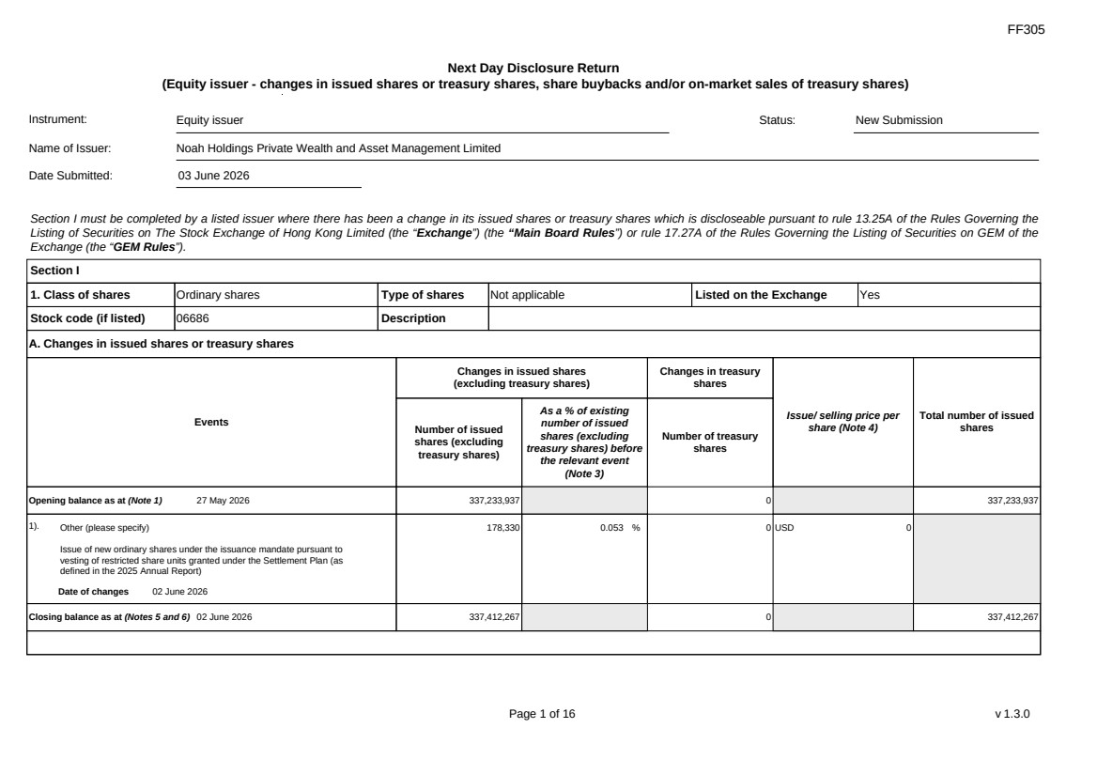 | FF305 Page 1 of 16 v 1.3.0 Next Day Disclosure Return (Equity issuer - changes in issued shares or treasury shares, share buybacks and/or on-market sales of treasury shares) Instrument: Equity issuer Status: New Submission Name of Issuer: Noah Holdings Private Wealth and Asset Management Limited Date Submitted: 03 June 2026 Section I must be completed by a listed issuer where there has been a change in its issued shares or treasury shares which is discloseable pursuant to rule 13.25A of the Rules Governing the Listing of Securities on The Stock Exchange of Hong Kong Limited (the “Exchange”) (the “Main Board Rules”) or rule 17.27A of the Rules Governing the Listing of Securities on GEM of the Exchange (the “GEM Rules”). Section I 1. Class of shares Ordinary shares Type of shares Not applicable Listed on the Exchange Yes Stock code (if listed) 06686 Description A. Changes in issued shares or treasury shares Events Changes in issued shares (excluding treasury shares) Number of issued shares (excluding treasury shares) As a % of existing number of issued shares (excluding treasury shares) before the relevant event (Note 3) Changes in treasury shares Number of treasury shares Issue/ selling price per share (Note 4) Total number of issued shares Opening balance as at (Note 1) 27 May 2026 337,233,937 0 337,233,937 1). Other (please specify) Issue of new ordinary shares under the issuance mandate pursuant to vesting of restricted share units granted under the Settlement Plan (as defined in the 2025 Annual Report) Date of changes 02 June 2026 178,330 0.053 % 0 USD 0 Closing balance as at (Notes 5 and 6) 02 June 2026 337,412,267 0 337,412,267
 | 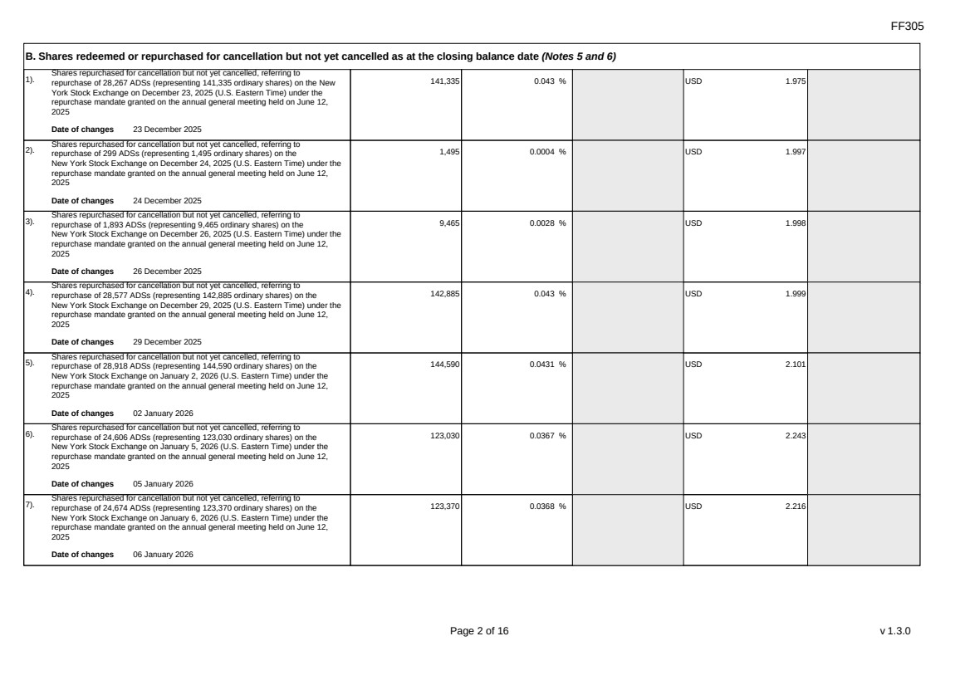 | FF305 Page 2 of 16 v 1.3.0 B. Shares redeemed or repurchased for cancellation but not yet cancelled as at the closing balance date (Notes 5 and 6) 1). Shares repurchased for cancellation but not yet cancelled, referring to repurchase of 28,267 ADSs (representing 141,335 ordinary shares) on the New York Stock Exchange on December 23, 2025 (U.S. Eastern Time) under the repurchase mandate granted on the annual general meeting held on June 12, 2025 Date of changes 23 December 2025 141,335 0.043 % USD 1.975 2). Shares repurchased for cancellation but not yet cancelled, referring to repurchase of 299 ADSs (representing 1,495 ordinary shares) on the New York Stock Exchange on December 24, 2025 (U.S. Eastern Time) under the repurchase mandate granted on the annual general meeting held on June 12, 2025 Date of changes 24 December 2025 1,495 0.0004 % USD 1.997 3). Shares repurchased for cancellation but not yet cancelled, referring to repurchase of 1,893 ADSs (representing 9,465 ordinary shares) on the New York Stock Exchange on December 26, 2025 (U.S. Eastern Time) under the repurchase mandate granted on the annual general meeting held on June 12, 2025 Date of changes 26 December 2025 9,465 0.0028 % USD 1.998 4). Shares repurchased for cancellation but not yet cancelled, referring to repurchase of 28,577 ADSs (representing 142,885 ordinary shares) on the New York Stock Exchange on December 29, 2025 (U.S. Eastern Time) under the repurchase mandate granted on the annual general meeting held on June 12, 2025 Date of changes 29 December 2025 142,885 0.043 % USD 1.999 5). Shares repurchased for cancellation but not yet cancelled, referring to repurchase of 28,918 ADSs (representing 144,590 ordinary shares) on the New York Stock Exchange on January 2, 2026 (U.S. Eastern Time) under the repurchase mandate granted on the annual general meeting held on June 12, 2025 Date of changes 02 January 2026 144,590 0.0431 % USD 2.101 6). Shares repurchased for cancellation but not yet cancelled, referring to repurchase of 24,606 ADSs (representing 123,030 ordinary shares) on the New York Stock Exchange on January 5, 2026 (U.S. Eastern Time) under the repurchase mandate granted on the annual general meeting held on June 12, 2025 Date of changes 05 January 2026 123,030 0.0367 % USD 2.243 7). Shares repurchased for cancellation but not yet cancelled, referring to repurchase of 24,674 ADSs (representing 123,370 ordinary shares) on the New York Stock Exchange on January 6, 2026 (U.S. Eastern Time) under the repurchase mandate granted on the annual general meeting held on June 12, 2025 Date of changes 06 January 2026 123,370 0.0368 % USD 2.216
 | 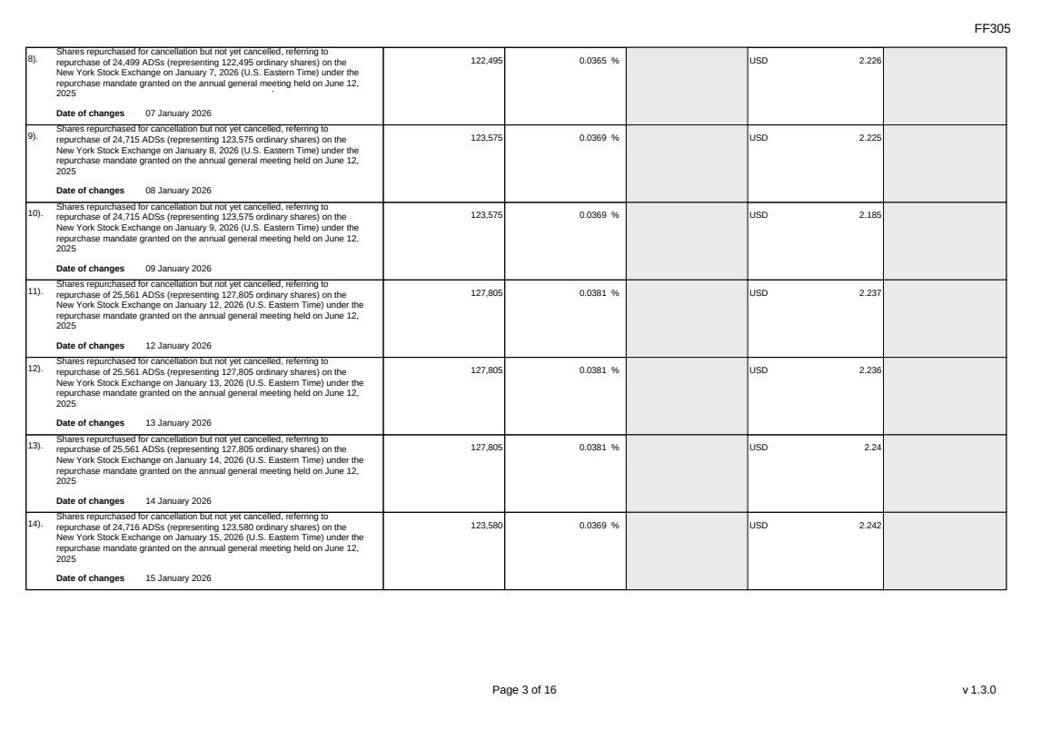 | FF305 Page 3 of 16 v 1.3.0 8). Shares repurchased for cancellation but not yet cancelled, referring to repurchase of 24,499 ADSs (representing 122,495 ordinary shares) on the New York Stock Exchange on January 7, 2026 (U.S. Eastern Time) under the repurchase mandate granted on the annual general meeting held on June 12, 2025 Date of changes 07 January 2026 122,495 0.0365 % USD 2.226 9). Shares repurchased for cancellation but not yet cancelled, referring to repurchase of 24,715 ADSs (representing 123,575 ordinary shares) on the New York Stock Exchange on January 8, 2026 (U.S. Eastern Time) under the repurchase mandate granted on the annual general meeting held on June 12, 2025 Date of changes 08 January 2026 123,575 0.0369 % USD 2.225 10). Shares repurchased for cancellation but not yet cancelled, referring to repurchase of 24,715 ADSs (representing 123,575 ordinary shares) on the New York Stock Exchange on January 9, 2026 (U.S. Eastern Time) under the repurchase mandate granted on the annual general meeting held on June 12, 2025 Date of changes 09 January 2026 123,575 0.0369 % USD 2.185 11). Shares repurchased for cancellation but not yet cancelled, referring to repurchase of 25,561 ADSs (representing 127,805 ordinary shares) on the New York Stock Exchange on January 12, 2026 (U.S. Eastern Time) under the repurchase mandate granted on the annual general meeting held on June 12, 2025 Date of changes 12 January 2026 127,805 0.0381 % USD 2.237 12). Shares repurchased for cancellation but not yet cancelled, referring to repurchase of 25,561 ADSs (representing 127,805 ordinary shares) on the New York Stock Exchange on January 13, 2026 (U.S. Eastern Time) under the repurchase mandate granted on the annual general meeting held on June 12, 2025 Date of changes 13 January 2026 127,805 0.0381 % USD 2.236 13). Shares repurchased for cancellation but not yet cancelled, referring to repurchase of 25,561 ADSs (representing 127,805 ordinary shares) on the New York Stock Exchange on January 14, 2026 (U.S. Eastern Time) under the repurchase mandate granted on the annual general meeting held on June 12, 2025 Date of changes 14 January 2026 127,805 0.0381 % USD 2.24 14). Shares repurchased for cancellation but not yet cancelled, referring to repurchase of 24,716 ADSs (representing 123,580 ordinary shares) on the New York Stock Exchange on January 15, 2026 (U.S. Eastern Time) under the repurchase mandate granted on the annual general meeting held on June 12, 2025 Date of changes 15 January 2026 123,580 0.0369 % USD 2.242
 | 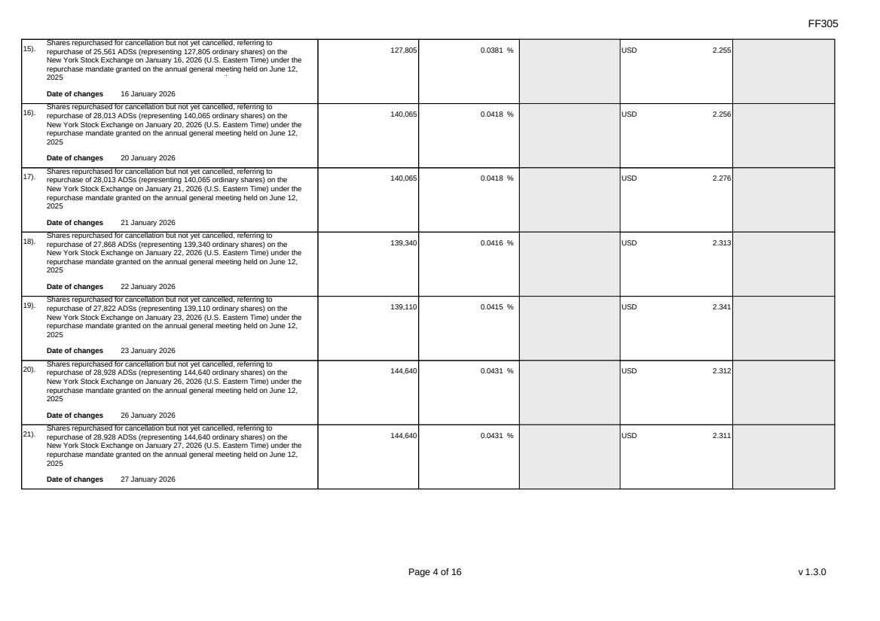 | FF305 Page 4 of 16 v 1.3.0 15). Shares repurchased for cancellation but not yet cancelled, referring to repurchase of 25,561 ADSs (representing 127,805 ordinary shares) on the New York Stock Exchange on January 16, 2026 (U.S. Eastern Time) under the repurchase mandate granted on the annual general meeting held on June 12, 2025 Date of changes 16 January 2026 127,805 0.0381 % USD 2.255 16). Shares repurchased for cancellation but not yet cancelled, referring to repurchase of 28,013 ADSs (representing 140,065 ordinary shares) on the New York Stock Exchange on January 20, 2026 (U.S. Eastern Time) under the repurchase mandate granted on the annual general meeting held on June 12, 2025 Date of changes 20 January 2026 140,065 0.0418 % USD 2.256 17). Shares repurchased for cancellation but not yet cancelled, referring to repurchase of 28,013 ADSs (representing 140,065 ordinary shares) on the New York Stock Exchange on January 21, 2026 (U.S. Eastern Time) under the repurchase mandate granted on the annual general meeting held on June 12, 2025 Date of changes 21 January 2026 140,065 0.0418 % USD 2.276 18). Shares repurchased for cancellation but not yet cancelled, referring to repurchase of 27,868 ADSs (representing 139,340 ordinary shares) on the New York Stock Exchange on January 22, 2026 (U.S. Eastern Time) under the repurchase mandate granted on the annual general meeting held on June 12, 2025 Date of changes 22 January 2026 139,340 0.0416 % USD 2.313 19). Shares repurchased for cancellation but not yet cancelled, referring to repurchase of 27,822 ADSs (representing 139,110 ordinary shares) on the New York Stock Exchange on January 23, 2026 (U.S. Eastern Time) under the repurchase mandate granted on the annual general meeting held on June 12, 2025 Date of changes 23 January 2026 139,110 0.0415 % USD 2.341 20). Shares repurchased for cancellation but not yet cancelled, referring to repurchase of 28,928 ADSs (representing 144,640 ordinary shares) on the New York Stock Exchange on January 26, 2026 (U.S. Eastern Time) under the repurchase mandate granted on the annual general meeting held on June 12, 2025 Date of changes 26 January 2026 144,640 0.0431 % USD 2.312 21). Shares repurchased for cancellation but not yet cancelled, referring to repurchase of 28,928 ADSs (representing 144,640 ordinary shares) on the New York Stock Exchange on January 27, 2026 (U.S. Eastern Time) under the repurchase mandate granted on the annual general meeting held on June 12, 2025 Date of changes 27 January 2026 144,640 0.0431 % USD 2.311
 | 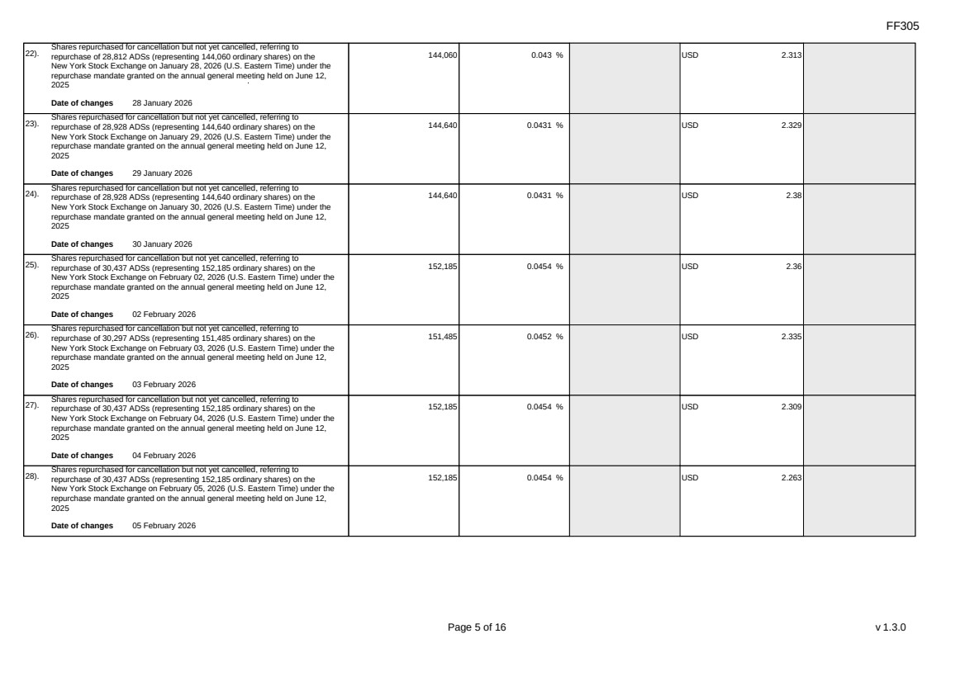 | FF305 Page 5 of 16 v 1.3.0 22). Shares repurchased for cancellation but not yet cancelled, referring to repurchase of 28,812 ADSs (representing 144,060 ordinary shares) on the New York Stock Exchange on January 28, 2026 (U.S. Eastern Time) under the repurchase mandate granted on the annual general meeting held on June 12, 2025 Date of changes 28 January 2026 144,060 0.043 % USD 2.313 23). Shares repurchased for cancellation but not yet cancelled, referring to repurchase of 28,928 ADSs (representing 144,640 ordinary shares) on the New York Stock Exchange on January 29, 2026 (U.S. Eastern Time) under the repurchase mandate granted on the annual general meeting held on June 12, 2025 Date of changes 29 January 2026 144,640 0.0431 % USD 2.329 24). Shares repurchased for cancellation but not yet cancelled, referring to repurchase of 28,928 ADSs (representing 144,640 ordinary shares) on the New York Stock Exchange on January 30, 2026 (U.S. Eastern Time) under the repurchase mandate granted on the annual general meeting held on June 12, 2025 Date of changes 30 January 2026 144,640 0.0431 % USD 2.38 25). Shares repurchased for cancellation but not yet cancelled, referring to repurchase of 30,437 ADSs (representing 152,185 ordinary shares) on the New York Stock Exchange on February 02, 2026 (U.S. Eastern Time) under the repurchase mandate granted on the annual general meeting held on June 12, 2025 Date of changes 02 February 2026 152,185 0.0454 % USD 2.36 26). Shares repurchased for cancellation but not yet cancelled, referring to repurchase of 30,297 ADSs (representing 151,485 ordinary shares) on the New York Stock Exchange on February 03, 2026 (U.S. Eastern Time) under the repurchase mandate granted on the annual general meeting held on June 12, 2025 Date of changes 03 February 2026 151,485 0.0452 % USD 2.335 27). Shares repurchased for cancellation but not yet cancelled, referring to repurchase of 30,437 ADSs (representing 152,185 ordinary shares) on the New York Stock Exchange on February 04, 2026 (U.S. Eastern Time) under the repurchase mandate granted on the annual general meeting held on June 12, 2025 Date of changes 04 February 2026 152,185 0.0454 % USD 2.309 28). Shares repurchased for cancellation but not yet cancelled, referring to repurchase of 30,437 ADSs (representing 152,185 ordinary shares) on the New York Stock Exchange on February 05, 2026 (U.S. Eastern Time) under the repurchase mandate granted on the annual general meeting held on June 12, 2025 Date of changes 05 February 2026 152,185 0.0454 % USD 2.263
 | 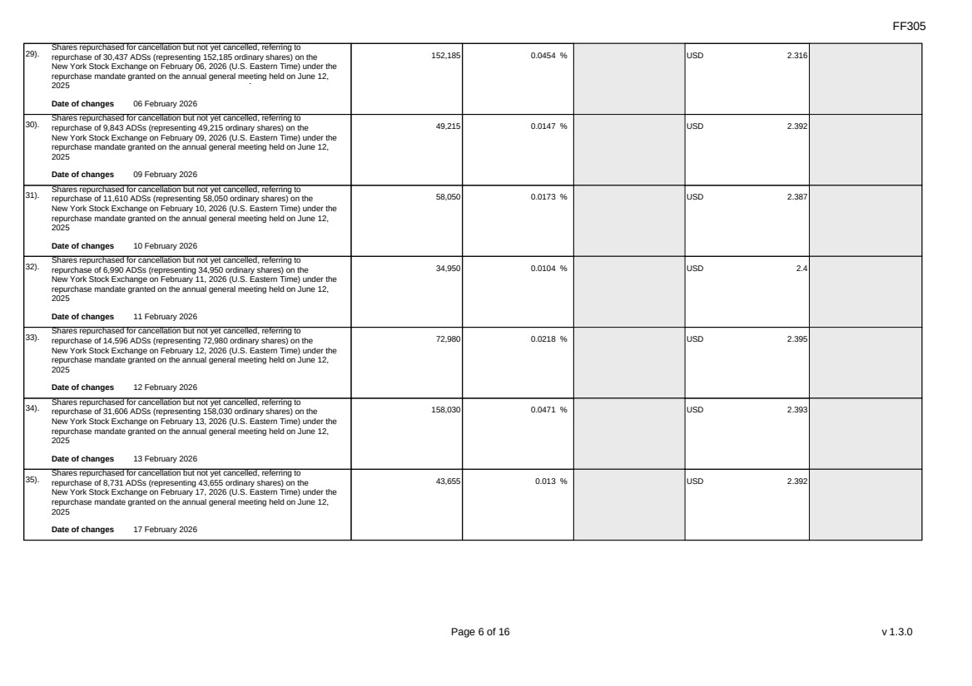 | FF305 Page 6 of 16 v 1.3.0 29). Shares repurchased for cancellation but not yet cancelled, referring to repurchase of 30,437 ADSs (representing 152,185 ordinary shares) on the New York Stock Exchange on February 06, 2026 (U.S. Eastern Time) under the repurchase mandate granted on the annual general meeting held on June 12, 2025 Date of changes 06 February 2026 152,185 0.0454 % USD 2.316 30). Shares repurchased for cancellation but not yet cancelled, referring to repurchase of 9,843 ADSs (representing 49,215 ordinary shares) on the New York Stock Exchange on February 09, 2026 (U.S. Eastern Time) under the repurchase mandate granted on the annual general meeting held on June 12, 2025 Date of changes 09 February 2026 49,215 0.0147 % USD 2.392 31). Shares repurchased for cancellation but not yet cancelled, referring to repurchase of 11,610 ADSs (representing 58,050 ordinary shares) on the New York Stock Exchange on February 10, 2026 (U.S. Eastern Time) under the repurchase mandate granted on the annual general meeting held on June 12, 2025 Date of changes 10 February 2026 58,050 0.0173 % USD 2.387 32). Shares repurchased for cancellation but not yet cancelled, referring to repurchase of 6,990 ADSs (representing 34,950 ordinary shares) on the New York Stock Exchange on February 11, 2026 (U.S. Eastern Time) under the repurchase mandate granted on the annual general meeting held on June 12, 2025 Date of changes 11 February 2026 34,950 0.0104 % USD 2.4 33). Shares repurchased for cancellation but not yet cancelled, referring to repurchase of 14,596 ADSs (representing 72,980 ordinary shares) on the New York Stock Exchange on February 12, 2026 (U.S. Eastern Time) under the repurchase mandate granted on the annual general meeting held on June 12, 2025 Date of changes 12 February 2026 72,980 0.0218 % USD 2.395 34). Shares repurchased for cancellation but not yet cancelled, referring to repurchase of 31,606 ADSs (representing 158,030 ordinary shares) on the New York Stock Exchange on February 13, 2026 (U.S. Eastern Time) under the repurchase mandate granted on the annual general meeting held on June 12, 2025 Date of changes 13 February 2026 158,030 0.0471 % USD 2.393 35). Shares repurchased for cancellation but not yet cancelled, referring to repurchase of 8,731 ADSs (representing 43,655 ordinary shares) on the New York Stock Exchange on February 17, 2026 (U.S. Eastern Time) under the repurchase mandate granted on the annual general meeting held on June 12, 2025 Date of changes 17 February 2026 43,655 0.013 % USD 2.392
 | 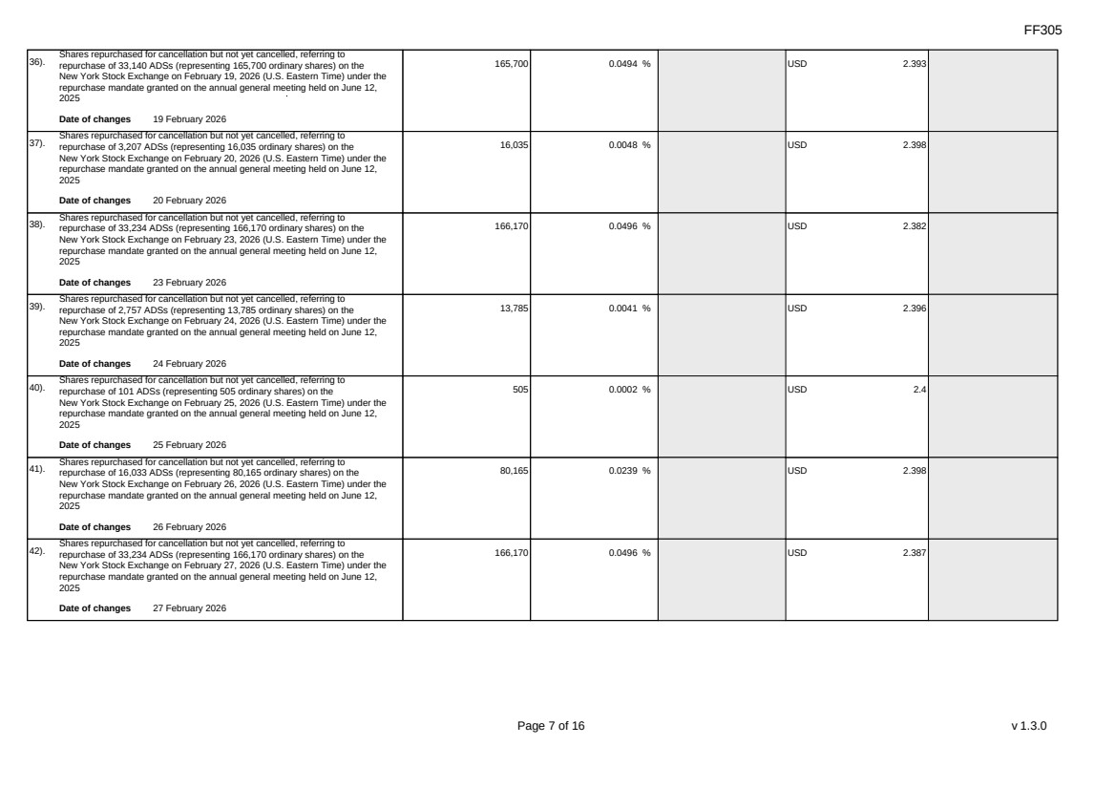 | FF305 Page 7 of 16 v 1.3.0 36). Shares repurchased for cancellation but not yet cancelled, referring to repurchase of 33,140 ADSs (representing 165,700 ordinary shares) on the New York Stock Exchange on February 19, 2026 (U.S. Eastern Time) under the repurchase mandate granted on the annual general meeting held on June 12, 2025 Date of changes 19 February 2026 165,700 0.0494 % USD 2.393 37). Shares repurchased for cancellation but not yet cancelled, referring to repurchase of 3,207 ADSs (representing 16,035 ordinary shares) on the New York Stock Exchange on February 20, 2026 (U.S. Eastern Time) under the repurchase mandate granted on the annual general meeting held on June 12, 2025 Date of changes 20 February 2026 16,035 0.0048 % USD 2.398 38). Shares repurchased for cancellation but not yet cancelled, referring to repurchase of 33,234 ADSs (representing 166,170 ordinary shares) on the New York Stock Exchange on February 23, 2026 (U.S. Eastern Time) under the repurchase mandate granted on the annual general meeting held on June 12, 2025 Date of changes 23 February 2026 166,170 0.0496 % USD 2.382 39). Shares repurchased for cancellation but not yet cancelled, referring to repurchase of 2,757 ADSs (representing 13,785 ordinary shares) on the New York Stock Exchange on February 24, 2026 (U.S. Eastern Time) under the repurchase mandate granted on the annual general meeting held on June 12, 2025 Date of changes 24 February 2026 13,785 0.0041 % USD 2.396 40). Shares repurchased for cancellation but not yet cancelled, referring to repurchase of 101 ADSs (representing 505 ordinary shares) on the New York Stock Exchange on February 25, 2026 (U.S. Eastern Time) under the repurchase mandate granted on the annual general meeting held on June 12, 2025 Date of changes 25 February 2026 505 0.0002 % USD 2.4 41). Shares repurchased for cancellation but not yet cancelled, referring to repurchase of 16,033 ADSs (representing 80,165 ordinary shares) on the New York Stock Exchange on February 26, 2026 (U.S. Eastern Time) under the repurchase mandate granted on the annual general meeting held on June 12, 2025 Date of changes 26 February 2026 80,165 0.0239 % USD 2.398 42). Shares repurchased for cancellation but not yet cancelled, referring to repurchase of 33,234 ADSs (representing 166,170 ordinary shares) on the New York Stock Exchange on February 27, 2026 (U.S. Eastern Time) under the repurchase mandate granted on the annual general meeting held on June 12, 2025 Date of changes 27 February 2026 166,170 0.0496 % USD 2.387
 | 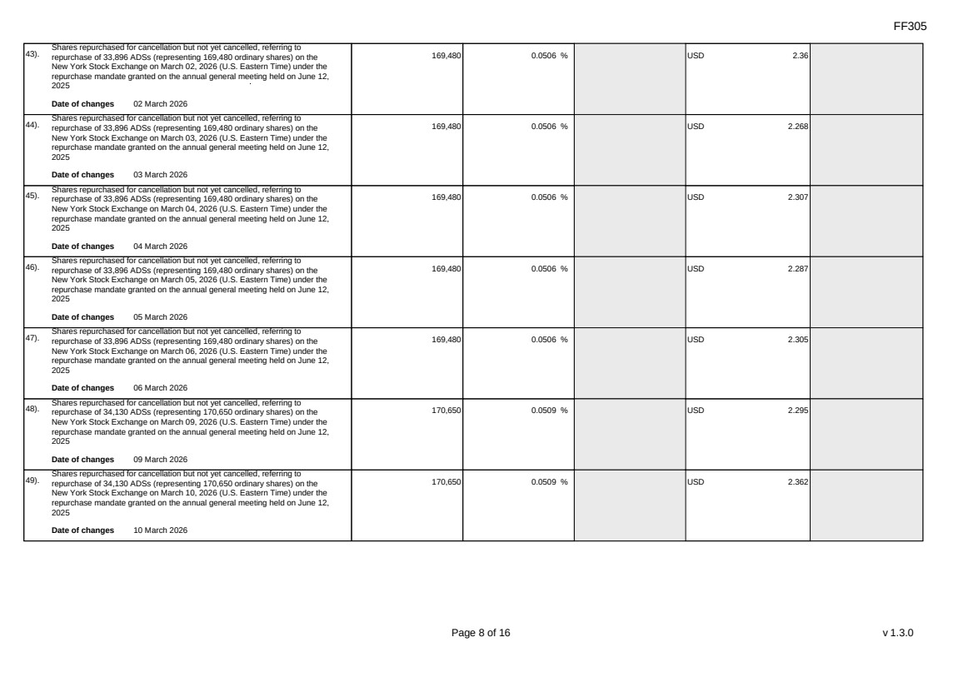 | FF305 Page 8 of 16 v 1.3.0 43). Shares repurchased for cancellation but not yet cancelled, referring to repurchase of 33,896 ADSs (representing 169,480 ordinary shares) on the New York Stock Exchange on March 02, 2026 (U.S. Eastern Time) under the repurchase mandate granted on the annual general meeting held on June 12, 2025 Date of changes 02 March 2026 169,480 0.0506 % USD 2.36 44). Shares repurchased for cancellation but not yet cancelled, referring to repurchase of 33,896 ADSs (representing 169,480 ordinary shares) on the New York Stock Exchange on March 03, 2026 (U.S. Eastern Time) under the repurchase mandate granted on the annual general meeting held on June 12, 2025 Date of changes 03 March 2026 169,480 0.0506 % USD 2.268 45). Shares repurchased for cancellation but not yet cancelled, referring to repurchase of 33,896 ADSs (representing 169,480 ordinary shares) on the New York Stock Exchange on March 04, 2026 (U.S. Eastern Time) under the repurchase mandate granted on the annual general meeting held on June 12, 2025 Date of changes 04 March 2026 169,480 0.0506 % USD 2.307 46). Shares repurchased for cancellation but not yet cancelled, referring to repurchase of 33,896 ADSs (representing 169,480 ordinary shares) on the New York Stock Exchange on March 05, 2026 (U.S. Eastern Time) under the repurchase mandate granted on the annual general meeting held on June 12, 2025 Date of changes 05 March 2026 169,480 0.0506 % USD 2.287 47). Shares repurchased for cancellation but not yet cancelled, referring to repurchase of 33,896 ADSs (representing 169,480 ordinary shares) on the New York Stock Exchange on March 06, 2026 (U.S. Eastern Time) under the repurchase mandate granted on the annual general meeting held on June 12, 2025 Date of changes 06 March 2026 169,480 0.0506 % USD 2.305 48). Shares repurchased for cancellation but not yet cancelled, referring to repurchase of 34,130 ADSs (representing 170,650 ordinary shares) on the New York Stock Exchange on March 09, 2026 (U.S. Eastern Time) under the repurchase mandate granted on the annual general meeting held on June 12, 2025 Date of changes 09 March 2026 170,650 0.0509 % USD 2.295 49). Shares repurchased for cancellation but not yet cancelled, referring to repurchase of 34,130 ADSs (representing 170,650 ordinary shares) on the New York Stock Exchange on March 10, 2026 (U.S. Eastern Time) under the repurchase mandate granted on the annual general meeting held on June 12, 2025 Date of changes 10 March 2026 170,650 0.0509 % USD 2.362
 | 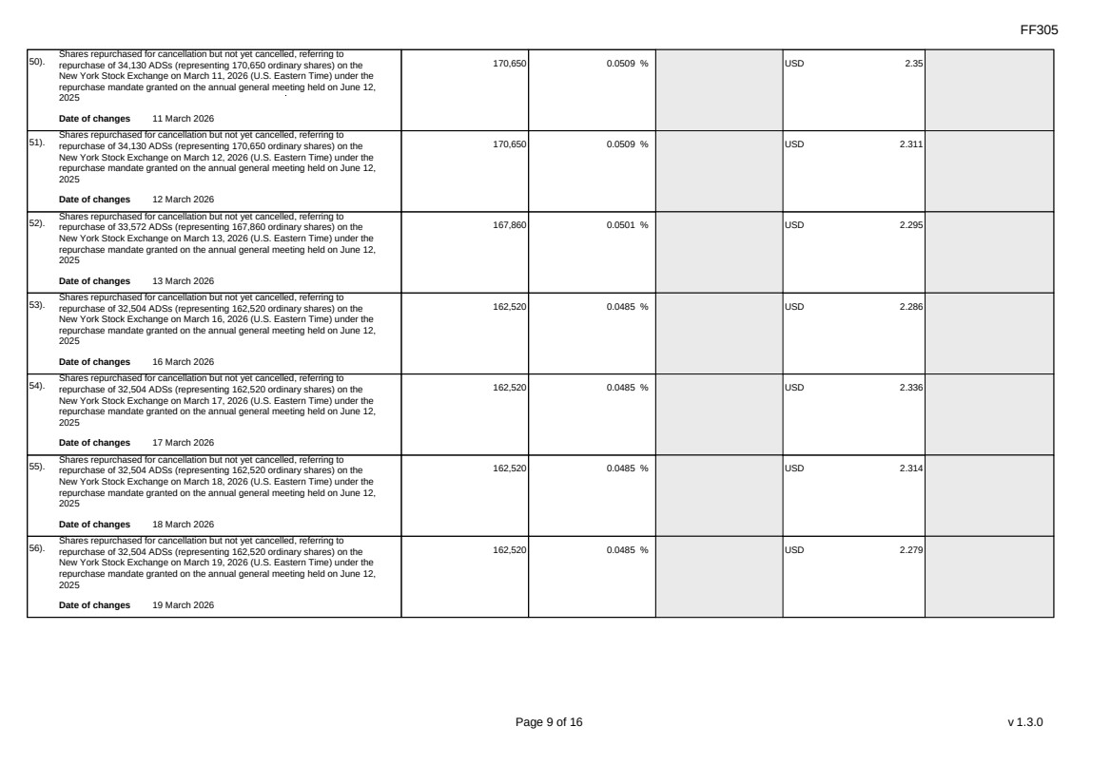 | FF305 Page 9 of 16 v 1.3.0 50). Shares repurchased for cancellation but not yet cancelled, referring to repurchase of 34,130 ADSs (representing 170,650 ordinary shares) on the New York Stock Exchange on March 11, 2026 (U.S. Eastern Time) under the repurchase mandate granted on the annual general meeting held on June 12, 2025 Date of changes 11 March 2026 170,650 0.0509 % USD 2.35 51). Shares repurchased for cancellation but not yet cancelled, referring to repurchase of 34,130 ADSs (representing 170,650 ordinary shares) on the New York Stock Exchange on March 12, 2026 (U.S. Eastern Time) under the repurchase mandate granted on the annual general meeting held on June 12, 2025 Date of changes 12 March 2026 170,650 0.0509 % USD 2.311 52). Shares repurchased for cancellation but not yet cancelled, referring to repurchase of 33,572 ADSs (representing 167,860 ordinary shares) on the New York Stock Exchange on March 13, 2026 (U.S. Eastern Time) under the repurchase mandate granted on the annual general meeting held on June 12, 2025 Date of changes 13 March 2026 167,860 0.0501 % USD 2.295 53). Shares repurchased for cancellation but not yet cancelled, referring to repurchase of 32,504 ADSs (representing 162,520 ordinary shares) on the New York Stock Exchange on March 16, 2026 (U.S. Eastern Time) under the repurchase mandate granted on the annual general meeting held on June 12, 2025 Date of changes 16 March 2026 162,520 0.0485 % USD 2.286 54). Shares repurchased for cancellation but not yet cancelled, referring to repurchase of 32,504 ADSs (representing 162,520 ordinary shares) on the New York Stock Exchange on March 17, 2026 (U.S. Eastern Time) under the repurchase mandate granted on the annual general meeting held on June 12, 2025 Date of changes 17 March 2026 162,520 0.0485 % USD 2.336 55). Shares repurchased for cancellation but not yet cancelled, referring to repurchase of 32,504 ADSs (representing 162,520 ordinary shares) on the New York Stock Exchange on March 18, 2026 (U.S. Eastern Time) under the repurchase mandate granted on the annual general meeting held on June 12, 2025 Date of changes 18 March 2026 162,520 0.0485 % USD 2.314 56). Shares repurchased for cancellation but not yet cancelled, referring to repurchase of 32,504 ADSs (representing 162,520 ordinary shares) on the New York Stock Exchange on March 19, 2026 (U.S. Eastern Time) under the repurchase mandate granted on the annual general meeting held on June 12, 2025 Date of changes 19 March 2026 162,520 0.0485 % USD 2.279
 | 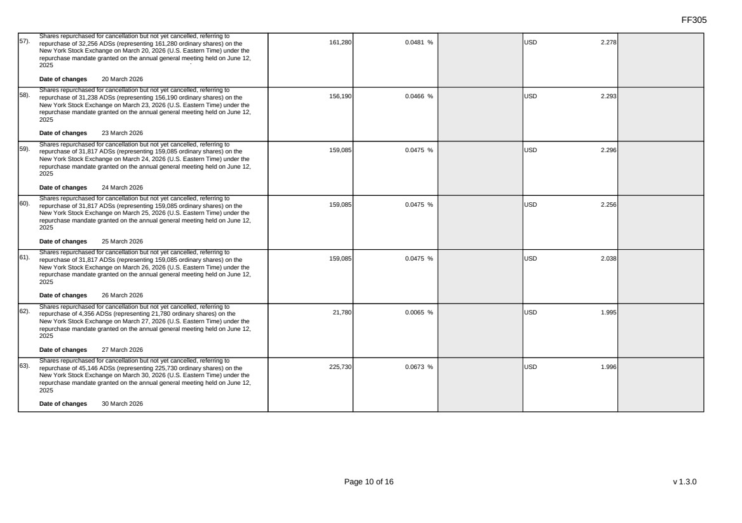 | FF305 Page 10 of 16 v 1.3.0 57). Shares repurchased for cancellation but not yet cancelled, referring to repurchase of 32,256 ADSs (representing 161,280 ordinary shares) on the New York Stock Exchange on March 20, 2026 (U.S. Eastern Time) under the repurchase mandate granted on the annual general meeting held on June 12, 2025 Date of changes 20 March 2026 161,280 0.0481 % USD 2.278 58). Shares repurchased for cancellation but not yet cancelled, referring to repurchase of 31,238 ADSs (representing 156,190 ordinary shares) on the New York Stock Exchange on March 23, 2026 (U.S. Eastern Time) under the repurchase mandate granted on the annual general meeting held on June 12, 2025 Date of changes 23 March 2026 156,190 0.0466 % USD 2.293 59). Shares repurchased for cancellation but not yet cancelled, referring to repurchase of 31,817 ADSs (representing 159,085 ordinary shares) on the New York Stock Exchange on March 24, 2026 (U.S. Eastern Time) under the repurchase mandate granted on the annual general meeting held on June 12, 2025 Date of changes 24 March 2026 159,085 0.0475 % USD 2.296 60). Shares repurchased for cancellation but not yet cancelled, referring to repurchase of 31,817 ADSs (representing 159,085 ordinary shares) on the New York Stock Exchange on March 25, 2026 (U.S. Eastern Time) under the repurchase mandate granted on the annual general meeting held on June 12, 2025 Date of changes 25 March 2026 159,085 0.0475 % USD 2.256 61). Shares repurchased for cancellation but not yet cancelled, referring to repurchase of 31,817 ADSs (representing 159,085 ordinary shares) on the New York Stock Exchange on March 26, 2026 (U.S. Eastern Time) under the repurchase mandate granted on the annual general meeting held on June 12, 2025 Date of changes 26 March 2026 159,085 0.0475 % USD 2.038 62). Shares repurchased for cancellation but not yet cancelled, referring to repurchase of 4,356 ADSs (representing 21,780 ordinary shares) on the New York Stock Exchange on March 27, 2026 (U.S. Eastern Time) under the repurchase mandate granted on the annual general meeting held on June 12, 2025 Date of changes 27 March 2026 21,780 0.0065 % USD 1.995 63). Shares repurchased for cancellation but not yet cancelled, referring to repurchase of 45,146 ADSs (representing 225,730 ordinary shares) on the New York Stock Exchange on March 30, 2026 (U.S. Eastern Time) under the repurchase mandate granted on the annual general meeting held on June 12, 2025 Date of changes 30 March 2026 225,730 0.0673 % USD 1.996
 | 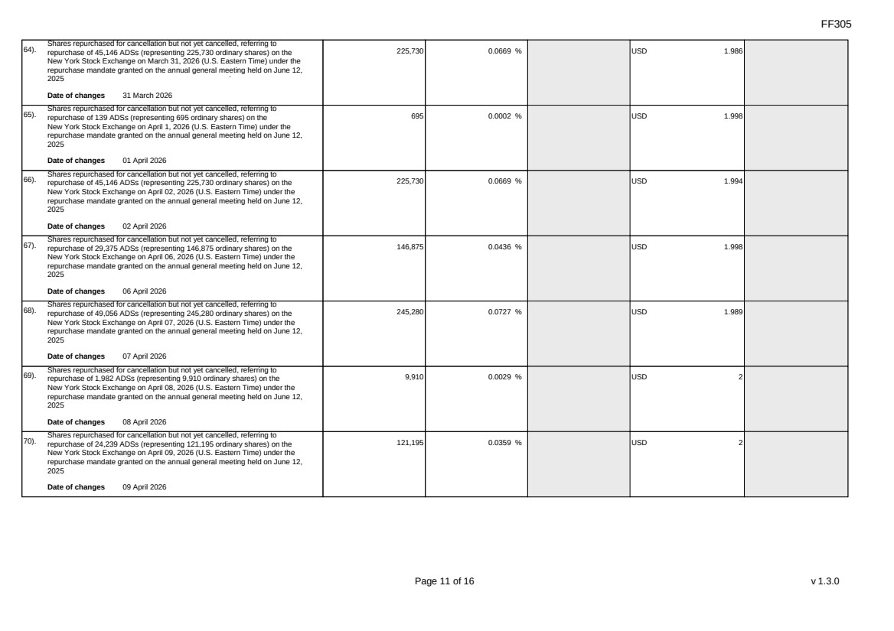 | FF305 Page 11 of 16 v 1.3.0 64). Shares repurchased for cancellation but not yet cancelled, referring to repurchase of 45,146 ADSs (representing 225,730 ordinary shares) on the New York Stock Exchange on March 31, 2026 (U.S. Eastern Time) under the repurchase mandate granted on the annual general meeting held on June 12, 2025 Date of changes 31 March 2026 225,730 0.0669 % USD 1.986 65). Shares repurchased for cancellation but not yet cancelled, referring to repurchase of 139 ADSs (representing 695 ordinary shares) on the New York Stock Exchange on April 1, 2026 (U.S. Eastern Time) under the repurchase mandate granted on the annual general meeting held on June 12, 2025 Date of changes 01 April 2026 695 0.0002 % USD 1.998 66). Shares repurchased for cancellation but not yet cancelled, referring to repurchase of 45,146 ADSs (representing 225,730 ordinary shares) on the New York Stock Exchange on April 02, 2026 (U.S. Eastern Time) under the repurchase mandate granted on the annual general meeting held on June 12, 2025 Date of changes 02 April 2026 225,730 0.0669 % USD 1.994 67). Shares repurchased for cancellation but not yet cancelled, referring to repurchase of 29,375 ADSs (representing 146,875 ordinary shares) on the New York Stock Exchange on April 06, 2026 (U.S. Eastern Time) under the repurchase mandate granted on the annual general meeting held on June 12, 2025 Date of changes 06 April 2026 146,875 0.0436 % USD 1.998 68). Shares repurchased for cancellation but not yet cancelled, referring to repurchase of 49,056 ADSs (representing 245,280 ordinary shares) on the New York Stock Exchange on April 07, 2026 (U.S. Eastern Time) under the repurchase mandate granted on the annual general meeting held on June 12, 2025 Date of changes 07 April 2026 245,280 0.0727 % USD 1.989 69). Shares repurchased for cancellation but not yet cancelled, referring to repurchase of 1,982 ADSs (representing 9,910 ordinary shares) on the New York Stock Exchange on April 08, 2026 (U.S. Eastern Time) under the repurchase mandate granted on the annual general meeting held on June 12, 2025 Date of changes 08 April 2026 9,910 0.0029 % USD 2 70). Shares repurchased for cancellation but not yet cancelled, referring to repurchase of 24,239 ADSs (representing 121,195 ordinary shares) on the New York Stock Exchange on April 09, 2026 (U.S. Eastern Time) under the repurchase mandate granted on the annual general meeting held on June 12, 2025 Date of changes 09 April 2026 121,195 0.0359 % USD 2
 | 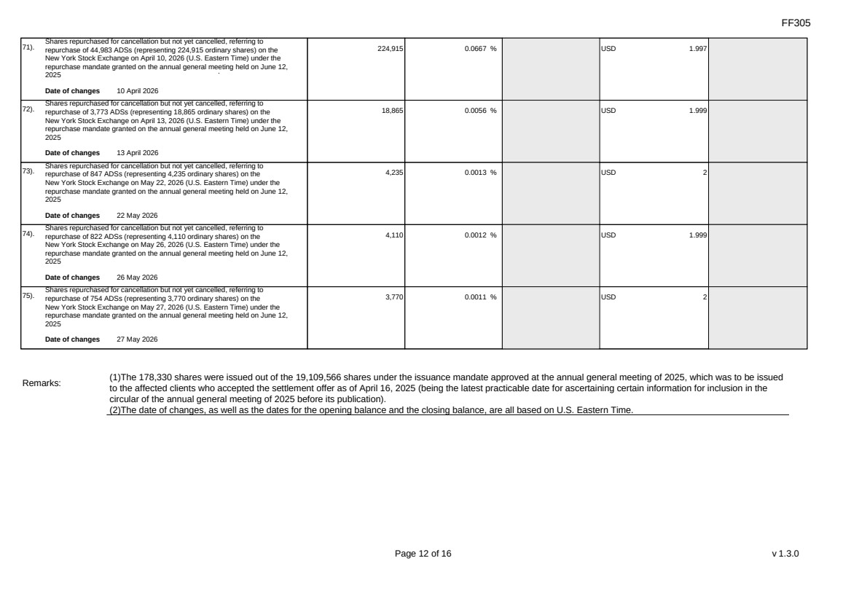 | FF305 Page 12 of 16 v 1.3.0 71). Shares repurchased for cancellation but not yet cancelled, referring to repurchase of 44,983 ADSs (representing 224,915 ordinary shares) on the New York Stock Exchange on April 10, 2026 (U.S. Eastern Time) under the repurchase mandate granted on the annual general meeting held on June 12, 2025 Date of changes 10 April 2026 224,915 0.0667 % USD 1.997 72). Shares repurchased for cancellation but not yet cancelled, referring to repurchase of 3,773 ADSs (representing 18,865 ordinary shares) on the New York Stock Exchange on April 13, 2026 (U.S. Eastern Time) under the repurchase mandate granted on the annual general meeting held on June 12, 2025 Date of changes 13 April 2026 18,865 0.0056 % USD 1.999 73). Shares repurchased for cancellation but not yet cancelled, referring to repurchase of 847 ADSs (representing 4,235 ordinary shares) on the New York Stock Exchange on May 22, 2026 (U.S. Eastern Time) under the repurchase mandate granted on the annual general meeting held on June 12, 2025 Date of changes 22 May 2026 4,235 0.0013 % USD 2 74). Shares repurchased for cancellation but not yet cancelled, referring to repurchase of 822 ADSs (representing 4,110 ordinary shares) on the New York Stock Exchange on May 26, 2026 (U.S. Eastern Time) under the repurchase mandate granted on the annual general meeting held on June 12, 2025 Date of changes 26 May 2026 4,110 0.0012 % USD 1.999 75). Shares repurchased for cancellation but not yet cancelled, referring to repurchase of 754 ADSs (representing 3,770 ordinary shares) on the New York Stock Exchange on May 27, 2026 (U.S. Eastern Time) under the repurchase mandate granted on the annual general meeting held on June 12, 2025 Date of changes 27 May 2026 3,770 0.0011 % USD 2 Remarks: (1)The 178,330 shares were issued out of the 19,109,566 shares under the issuance mandate approved at the annual general meeting of 2025, which was to be issued to the affected clients who accepted the settlement offer as of April 16, 2025 (being the latest practicable date for ascertaining certain information for inclusion in the circular of the annual general meeting of 2025 before its publication). (2)The date of changes, as well as the dates for the opening balance and the closing balance, are all based on U.S. Eastern Time.
 | 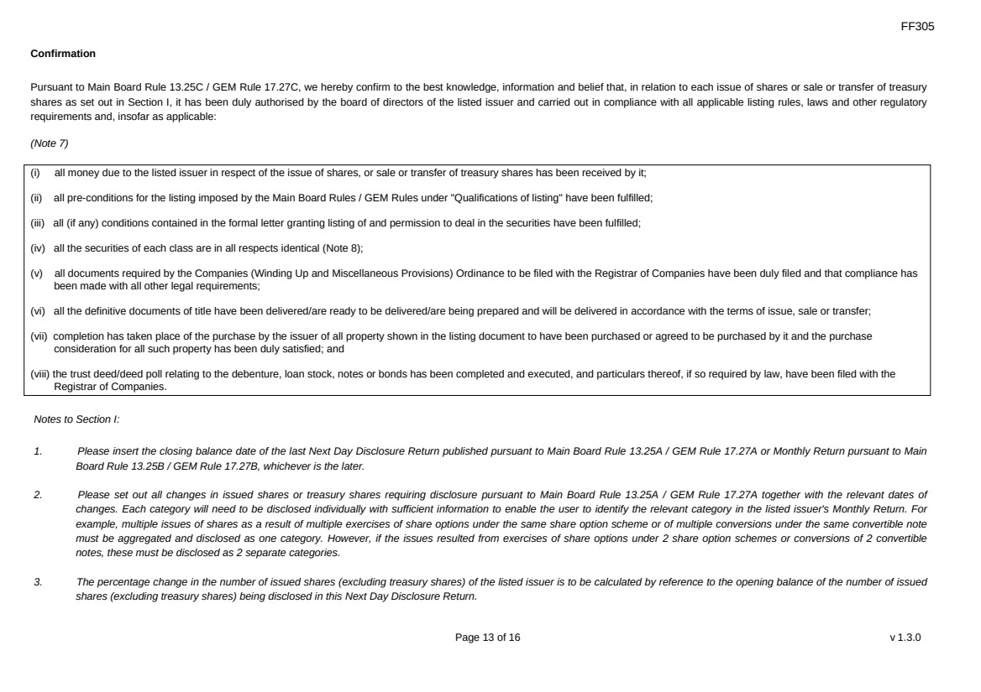 | FF305 Page 13 of 16 v 1.3.0 Confirmation Pursuant to Main Board Rule 13.25C / GEM Rule 17.27C, we hereby confirm to the best knowledge, information and belief that, in relation to each issue of shares or sale or transfer of treasury shares as set out in Section I, it has been duly authorised by the board of directors of the listed issuer and carried out in compliance with all applicable listing rules, laws and other regulatory requirements and, insofar as applicable: (Note 7) (i) all money due to the listed issuer in respect of the issue of shares, or sale or transfer of treasury shares has been received by it; (ii) all pre-conditions for the listing imposed by the Main Board Rules / GEM Rules under "Qualifications of listing" have been fulfilled; (iii) all (if any) conditions contained in the formal letter granting listing of and permission to deal in the securities have been fulfilled; (iv) all the securities of each class are in all respects identical (Note 8); (v) all documents required by the Companies (Winding Up and Miscellaneous Provisions) Ordinance to be filed with the Registrar of Companies have been duly filed and that compliance has been made with all other legal requirements; (vi) all the definitive documents of title have been delivered/are ready to be delivered/are being prepared and will be delivered in accordance with the terms of issue, sale or transfer; (vii) completion has taken place of the purchase by the issuer of all property shown in the listing document to have been purchased or agreed to be purchased by it and the purchase consideration for all such property has been duly satisfied; and (viii) the trust deed/deed poll relating to the debenture, loan stock, notes or bonds has been completed and executed, and particulars thereof, if so required by law, have been filed with the Registrar of Companies. Notes to Section I: 1. Please insert the closing balance date of the last Next Day Disclosure Return published pursuant to Main Board Rule 13.25A / GEM Rule 17.27A or Monthly Return pursuant to Main Board Rule 13.25B / GEM Rule 17.27B, whichever is the later. 2. Please set out all changes in issued shares or treasury shares requiring disclosure pursuant to Main Board Rule 13.25A / GEM Rule 17.27A together with the relevant dates of changes. Each category will need to be disclosed individually with sufficient information to enable the user to identify the relevant category in the listed issuer's Monthly Return. For example, multiple issues of shares as a result of multiple exercises of share options under the same share option scheme or of multiple conversions under the same convertible note must be aggregated and disclosed as one category. However, if the issues resulted from exercises of share options under 2 share option schemes or conversions of 2 convertible notes, these must be disclosed as 2 separate categories. 3. The percentage change in the number of issued shares (excluding treasury shares) of the listed issuer is to be calculated by reference to the opening balance of the number of issued shares (excluding treasury shares) being disclosed in this Next Day Disclosure Return.
 | 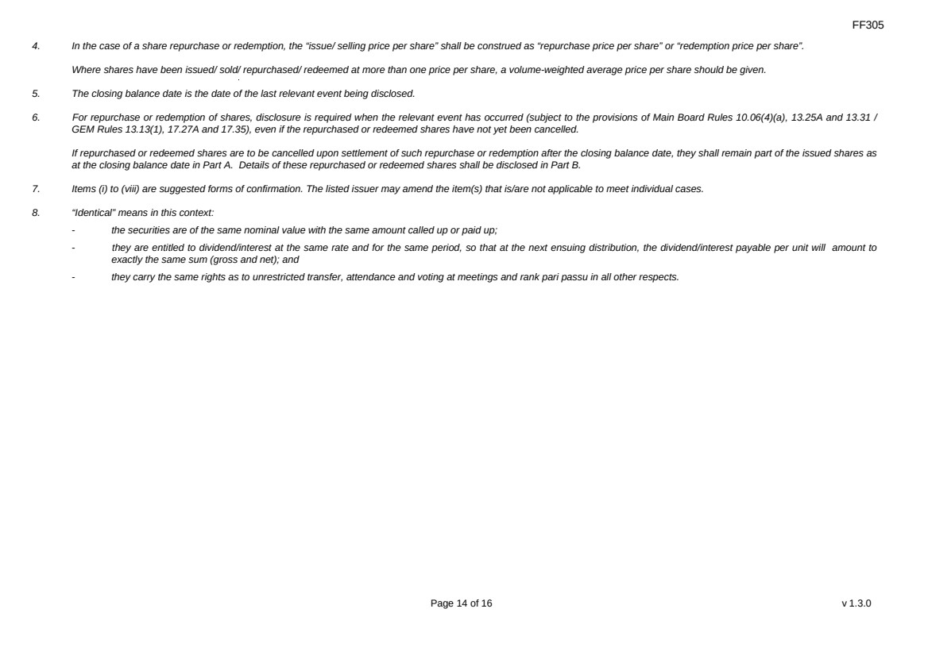 | FF305 Page 14 of 16 v 1.3.0 4. In the case of a share repurchase or redemption, the “issue/ selling price per share” shall be construed as “repurchase price per share” or “redemption price per share”. Where shares have been issued/ sold/ repurchased/ redeemed at more than one price per share, a volume-weighted average price per share should be given. 5. The closing balance date is the date of the last relevant event being disclosed. 6. For repurchase or redemption of shares, disclosure is required when the relevant event has occurred (subject to the provisions of Main Board Rules 10.06(4)(a), 13.25A and 13.31 / GEM Rules 13.13(1), 17.27A and 17.35), even if the repurchased or redeemed shares have not yet been cancelled. If repurchased or redeemed shares are to be cancelled upon settlement of such repurchase or redemption after the closing balance date, they shall remain part of the issued shares as at the closing balance date in Part A. Details of these repurchased or redeemed shares shall be disclosed in Part B. 7. Items (i) to (viii) are suggested forms of confirmation. The listed issuer may amend the item(s) that is/are not applicable to meet individual cases. 8. “Identical” means in this context: - the securities are of the same nominal value with the same amount called up or paid up; - they are entitled to dividend/interest at the same rate and for the same period, so that at the next ensuing distribution, the dividend/interest payable per unit will amount to exactly the same sum (gross and net); and - they carry the same rights as to unrestricted transfer, attendance and voting at meetings and rank pari passu in all other respects.
 | 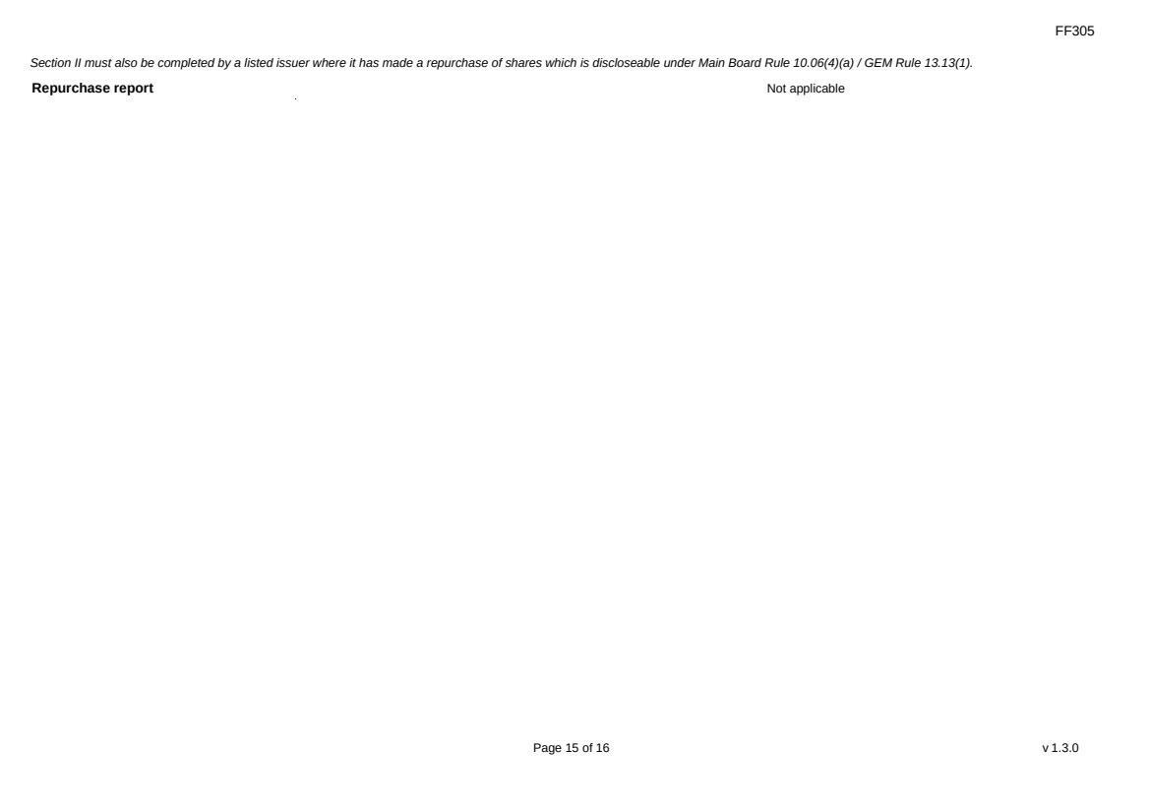 | FF305 Page 15 of 16 v 1.3.0 Section II must also be completed by a listed issuer where it has made a repurchase of shares which is discloseable under Main Board Rule 10.06(4)(a) / GEM Rule 13.13(1). Repurchase report Not applicable
 | 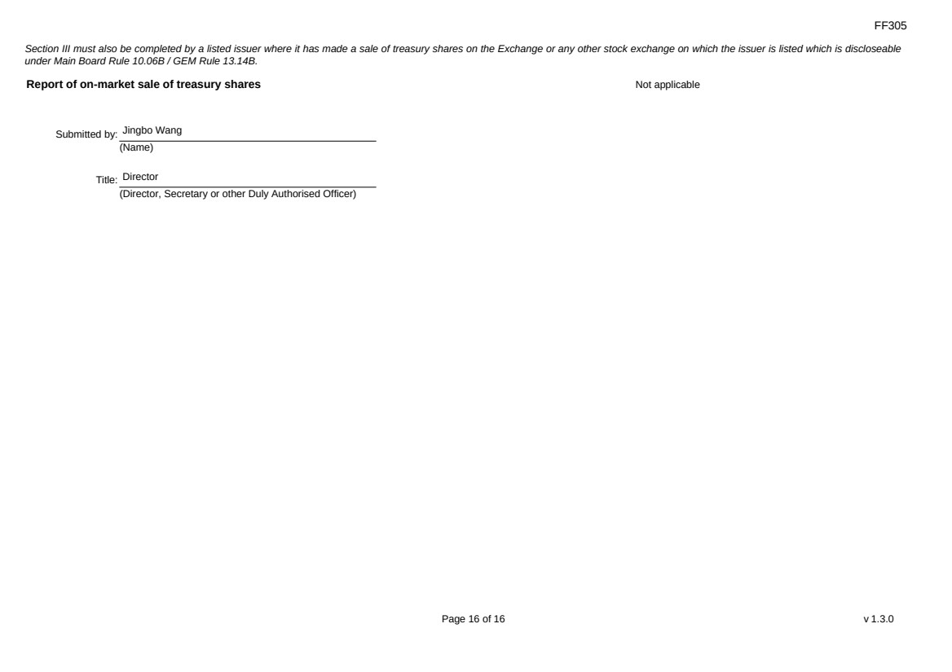 | FF305 Page 16 of 16 v 1.3.0 Section III must also be completed by a listed issuer where it has made a sale of treasury shares on the Exchange or any other stock exchange on which the issuer is listed which is discloseable under Main Board Rule 10.06B / GEM Rule 13.14B. Report of on-market sale of treasury shares Not applicable Submitted by: Jingbo Wang (Name) Title: Director (Director, Secretary or other Duly Authorised Officer)

